Usability Engineering – Assignment 1

Nachiket Rao

s3827657

RMIT University

Abstract

This report compares the usability of two websites on the topic of sustainability in an IT business. The websites were evaluated by weighing each parameter from Whitney Quesenbery’s 5 E’s. User evaluation was done through observing a focus group of five people who were given a certain set of questions that were to be answered through scoping the websites. Each person in the group was later interviewed to document their user experience in performing the tasks. The usability of the websites was assessed based on whether the users were able to successfully retrieve the information and their overall experience in navigating the UI.

Keywords: usability, 5 E’s, evaluation, user experience

**Introduction**

Usability and Utility, as described by Nielsen [3], are characteristics that assess how effortless the user interface is to use and whether the user was able to complete the task they set out to do. Neatly summarized by Quesenbery – “Usability is the characteristic of a product that meets the needs of people who use it and, in a way, appropriate to them” [1]. There are various factors involved in measuring the usability of a product. The factors vary depending on the intended use of the product, target audience for whom the product is designed and lastly the individual who uses that product. However so, usability measurement can be generalized by boiling it down to certain key facets. For the context of this report, I have chosen to evaluate usability by utilizing Quesenbery’s 5E’s.

# Test Methodology

**End User Description:**

User evaluating the websites is assumed to be an employee of an IT firm that provides cloud services such as virtual machines, SaaS and PaaS. As more and more companies are scrambling towards making their businesses sustainable, the management of this IT firm have decided to increase sales by marketing the cloud services offered as solutions to making business sustainable. The employee is tasked with finding out common sustainability issues faced by most business and what areas relating to sustainability can cloud services facilitate.

## Websites to be evaluated

1. <https://sustainabledevelopment.un.org/>
2. <https://www.imd.org/research-knowledge/sustainability/>

## Test Description

Following tasks were supplied to the people in the focus group:

1. Is it clear from this website what sustainability means?
2. Does the website give information on how sustainability might relate to an IT business in Australia? If so, where and what kind of information does it provide?
3. Why is it important for a business to be sustainable?
4. What are some steps and/or examples of achieving business sustainability?
5. How would you rate the overall usability of this website for finding the relevant information?

For evaluation, each website was given 30 minutes within which the group had to search for the answers. While answering these questions, the group was observed as to how they set out to obtain the information from the websites. Once done, the people in the group were asked to fill out a form and later interviewed to discern their individual experiences which was then weighed against the 5E’s to understand the usability of the websites.

Following questions were asked during the interview:

1. Was the user interface pleasant enough for you to continue browsing the website further?
2. Who do you feel is the target audience for the website? Is the website usable for that end user?
3. Which aspect of the website would you say hindered (or perhaps bolstered) the usability?

### Results and Observations

1. **SDGS Website:**

* Lackluster user interface
* Confusing navigation bar
* Information written in a formal manner with technical jargons
* Acronyms that user is expected to know scattered all over the website

**Qualitative Analysis:**

Interview conducted with the users post completion of the tasks concluded that the overall impression of the website was negative. General comments made about the website were about the language that the information within the website was written in which was primarily technical consisting of little to no relevant information that the users was tasked with retrieving. While the website did provide a definitive list of goals relating to sustainability (as advertised by the URL of the site itself), it failed to elaborate on those goals from a business perspective. The website instead comprised largely of logs and records of goals achieved by governing bodies from various nations.

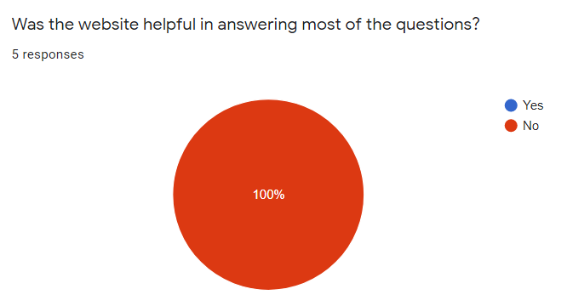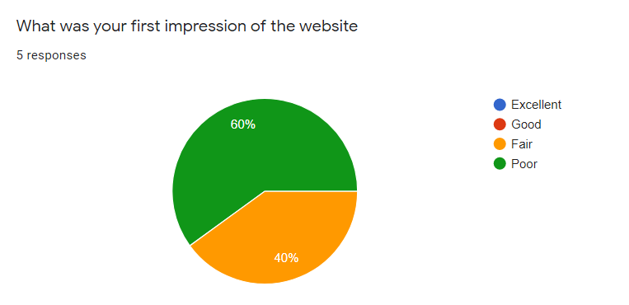**Quantitative Observation:**

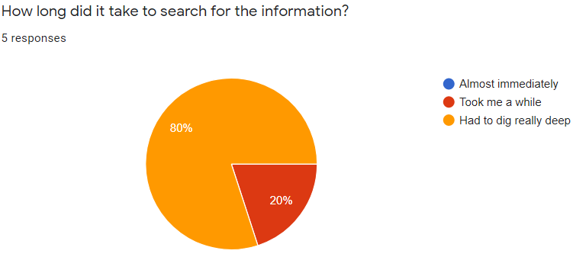

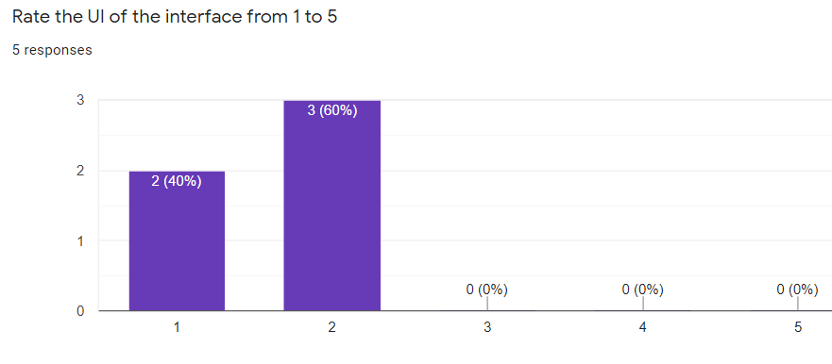

**5E Evaluation:**

1. **Effective:** 2/5

None of the users were able to find relevant information and were unable to answer the questions given to them.

1. **Efficient:** 1/5

In addition to not finding information, the users had to navigate the website a lot that suggests that the user interface of the website is not efficient

1. **Engaging:** 1/5

On a scale of 1 to 5, all the users rated the user interface of the website between 1 and 2 (1 being poor)

1. **Error Tolerant:** 3/5

No broken links reported, however bread crumb trail not consistent in all pages

1. **Easy to Learn:** 2/5

Presence of unexplained acronyms, technical jargons, intensely formal language which makes the website a tough read.

**Proposals to improve usability:**

* Include a section that explicitly defines each of the 17 sustainable development goals
* Collapsible list on the navigation bar to help the user better navigate

1. **IMD Website:**

* Relevant information found immediately
* Inclusion of a global search widget
* UI is pleasant and inviting
* Reading time specified for every article
* Short summary of the article/report along with links to download the full-length PDF

**Qualitative Analysis:**

All the users immediately clicked on the 3rd link that contained the keyword “business”, “sustainability” and “embrace”. Links to different articles were laid out properly in a structured manner and majority of the links on the first half of the webpage contained relevant information relating to business sustainability. The webpage contained essential information along with examples from real companies on how they have made their business sustainable and the outcomes of doing so. The presence of a global menu and search widget made the website far effortless to navigate through for searching information.

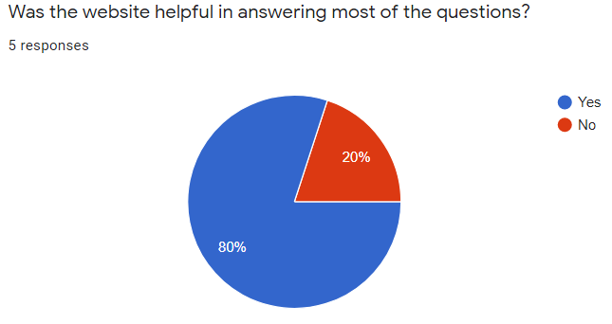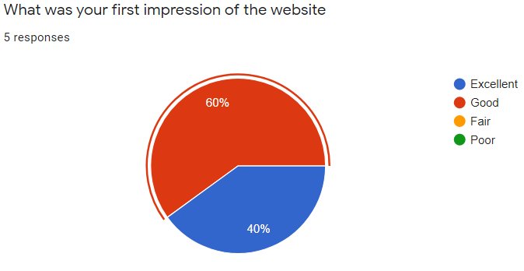**Quantitative Observation:**

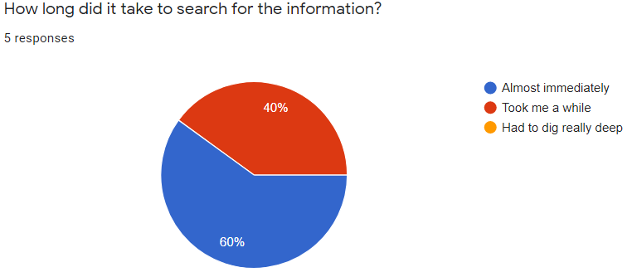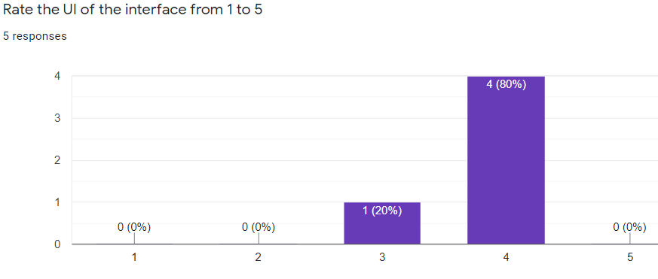

**5E Evaluation:**

1. **Effective:** 4/5

Relevant information was found almost immediately owing to the layout and the articles provided by the website

1. **Efficient:** 3/5

Users can understand the length of any article/report looking at the time required for reading which is provided below each article link.

1. **Engaging:** 5/5

As shown in the bar graph, most of the users liked the UI of the website. The layout of the information and the language in the articles was inviting

1. **Error Tolerant:** 4/5

Collapsible menu along with the scroll back to top widget and consistent bread crumb navigation trail maintained in all pages.

1. **Easy to Learn:** 4/5

All 5 users behaved in a similar way while navigating the website and the presence of a search widget makes the website easy to learn.

**Proposals to improve usability:**

* A better layout of the information fetched from the search algorithm

### Conclusion

The SDGS website, as represented by the results and as suggested by the users, fails to satisfy most of the usability parameters in this scenario. The most conspicuous element of the website is the 17 goals of sustainable development which is listed out clearly in the homepage and gives the users a universal view of sustainability related topics yet fails to elaborate on them from a business perspective.

The IMD website, in addition to the more pleasing UI, straightaway provides a glimpse of the information that the users were tasked with searching i.e. a view of sustainability from a business perspective which prompts the users to stay and browse the website further. While the users did use the global search bar, it did not return much tangible information. The website also links the SDGS website tying it together with business. Full length reports also made available for download by the website along with a contextual overview for those who do not wish to read the entire document.

### Limitations

* Testing methodology limited to a focus group of 5 people
* 30 minutes time limit effectuated for completion of tasks
* Users had no prior knowledge of sustainability

### Proposition for further research

* As suggested by Jacob Nielsen, 3-4 users from each category should be considered while testing usability
* Diversification of users from different backgrounds
* Identifying the correct target user of the website for an accurate evaluation

### References

[1] Quesenbury, W., 2004. Balancing the 5Es: Usability. Cutter IT Journal, 17(2), pp.4-11.

[2] Nielsen, J., 2000. Why You Only Need To Test With 5 Users. [online] Nielsen Norman

Group. Available at: <https://www.nngroup.com/articles/why-you-only-need-to-test-with-users/>

[Accessed 18 March 2020]

[3] Nielsen, J., 2012. *Usability 101: Introduction To Usability*. [online] Nielsen Norman Group.

Available at: <https://www.nngroup.com/articles/usability-101-introduction-to-usability/>

[Accessed 21 March 2020].